

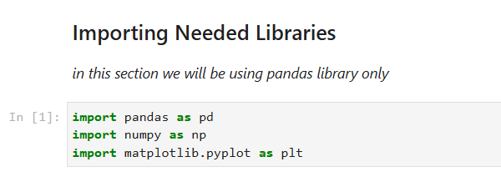
Using pandas library to organize data into DataFrame

------------------------------------------------------------------------------------------------------------

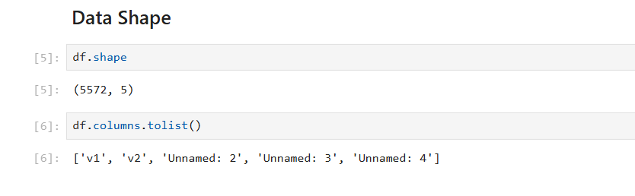

Our data has 5572 rows and 5 columns: “v1”, “v2”,and three unnamed columns.
So we need to remove those unnamed mostly empty columns.

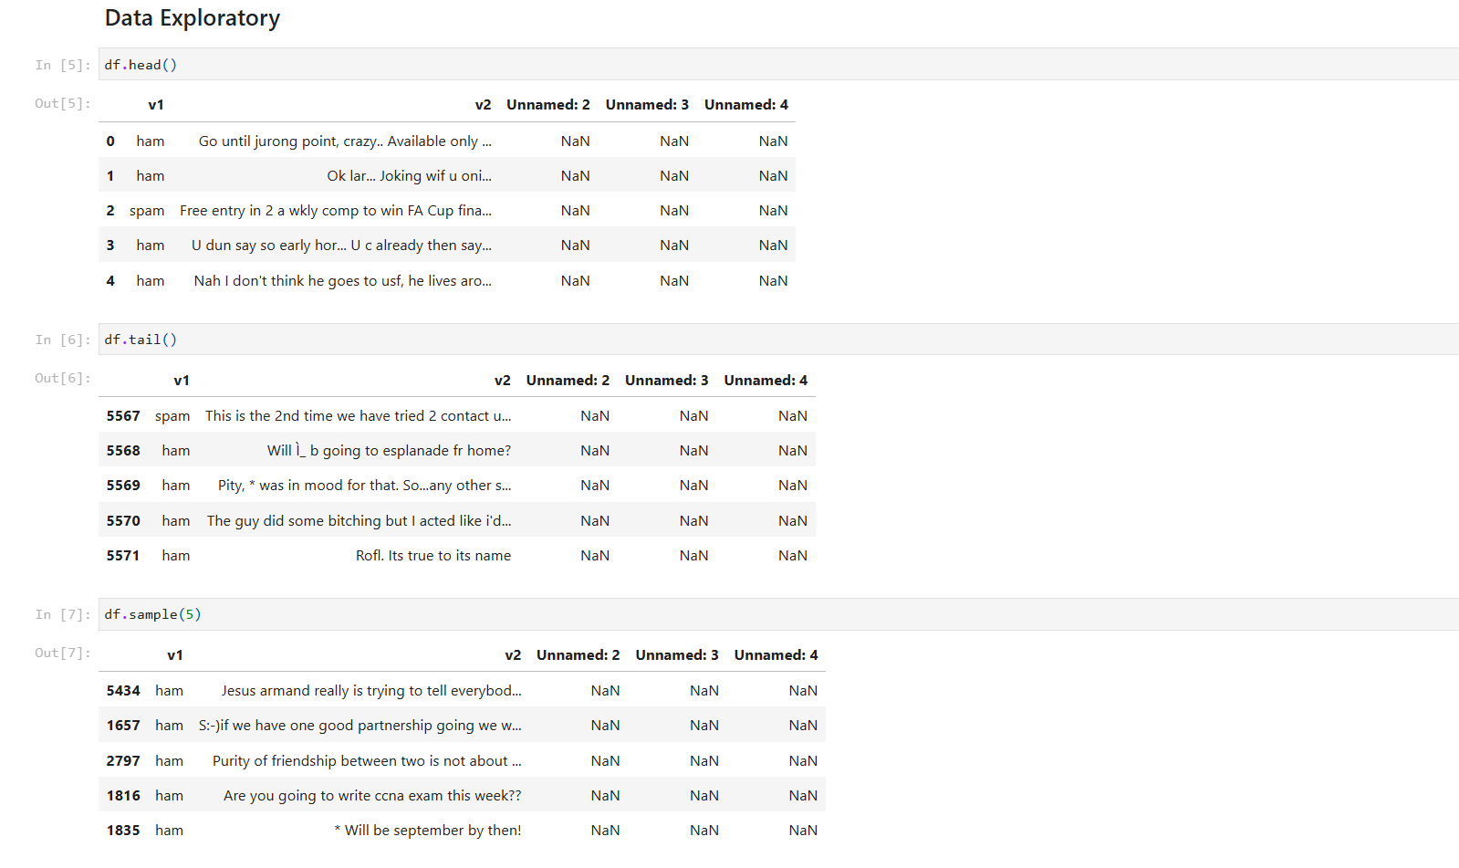
head() and tail() will by default show us first and last five items in our dataset.
Sample(5): gave us 5 random items.

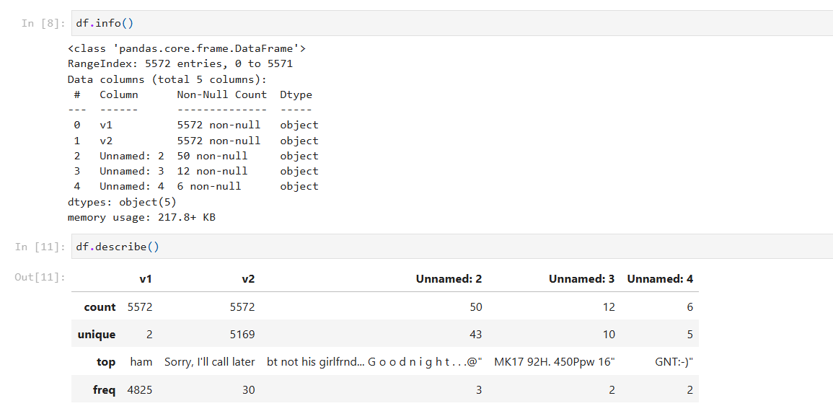
v1 and v2 columns have 5572 non-null values out of 5572 , which means they are clean.
Unnamed 2,3 and 4 columns have 50,12 and 6 non-null values out of 5572, which means they’re mostly empty and need to be cleaned up or removed.

---------------------------------------------------------------------------------------------------------------
-
v1 column : has 5572 values , only 2 items are unique (spam and ham), ham is the most frequent and has been repeated 4825 times, which means that most of the emails are ham.
v2 column : has 5572 values , 5169 items are unique , which means there are 403 repeated values,
“Sorry, I’ll call later” is mostly repeated and has been repeated 30 times.
(ignoring the three unnamed columns since we won’t need them anyways)
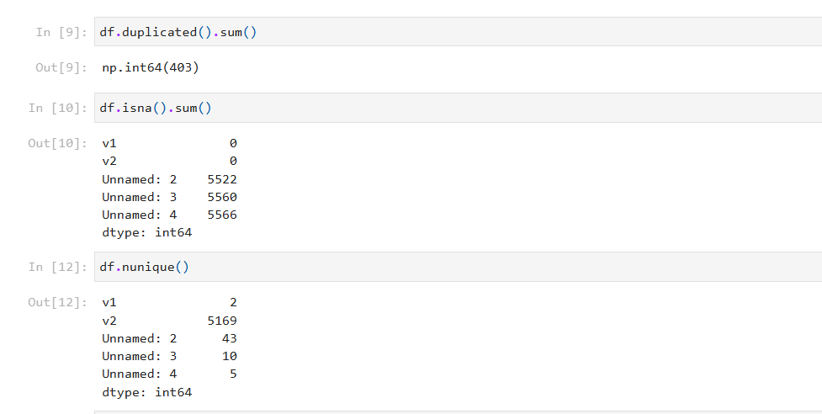
There are 403 repeated values in our dataset, as we saw

before in v2 column ,that need to be removed.

v1 and v2 have 0 null values, which means they’re clean.

The three unnamed columns have more than 5560 null values, which means they need to be removed.

our dataset has :
- 2 unique values in column v1
- 5169 unique values in column v2

summary
Our dataset has 403 repeated values,
three unnamed columns that have more than 5560 null values,
Both need to be removed.

----------------------------------------------------

Data Processing : Alaa Agha and Habiba Baligh
Data Analysis & Documentation : Habiba Hossam

